ACCT11081 Assignment: Steps 9
Melissa Sergiacomi 12099798

Incitec Pivot Limited (IPL) are a large company with two customer facing businesses that have 66 manufacturing facilities and joint ventures across five continents. For this step I have based my transactions on IPL’s fertiliser business, Incitec Pivot Fertilisers (IPF) (which is combined with Southern Cross International), which are the largest domestic manufacture and supplier of fertilisers by volume. I decided for my hypothetical transactions I would do both purchases and sales to get a good range for the journals. Researching through the annual report for 2019 I discovered that the Phosphate Hill plant is expected to benefit in 2020 from a full year of lower cost of Northern Territory gas supply reducing their gas costs by approximately $8m compared to 2019. This discovery has led me to use high figures as my finding reiterates how large my company for this unit is, even just in Australia.
Hypothetical Business Transactions:
Date | Amount | Item | Payment Details
1/8/2020 | -$243,000 | Expense- Gas Supply Bill – Ergon Energy Northern Territory | Paid 28/08/20
3/8/2020 | $450,657.90 | Sales of Ammonium Phosphate Fertiliser to Grow Force | Paid 27/8/20
3/8/2020 | $30,237.90 | Sales of Ammonium Phosphate Fertiliser to Topsfield farms | Paid 27/8/20
5/8/2020 | -$140,760 | Expense- Repairs on vehicle performed by Fix ‘R’ Us Mechanics | Paid 31/8/20
7/8/2020 | -$200,000 | Expense- Lease of warehouse from Betty Jones | Paid 4/9/20
11/8/2020 | $363,546 | Sales of Single Super Phosphate Fertiliser to Grow Force | Paid 1/9/20
13/8/2020 | $40,018 | Sales of Granulated Ammonium Fertiliser to S & D Produce | Paid 27/08/20
14/8/2020 | -$127,187 | Expense- Water supply – Northern Territory Council | Paid 7/9/20
17/8/2020 | $252,396 | Sales of Single Super Phosphate Fertiliser to Chemical Warehouse | Paid 7/9/20
24/8/2020 | $450,657.90 | Sales of Ammonium Phosphate Fertiliser to Grow Force | Paid 7/9/20

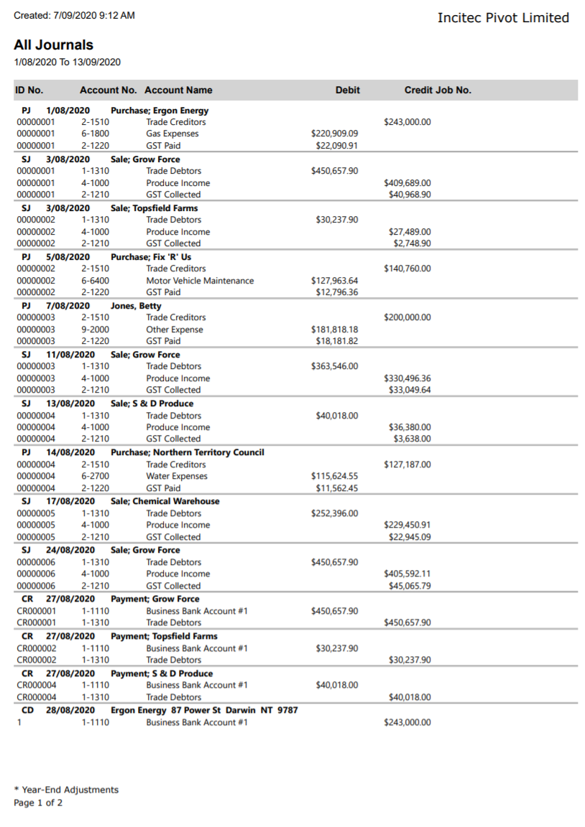
All Journal Report
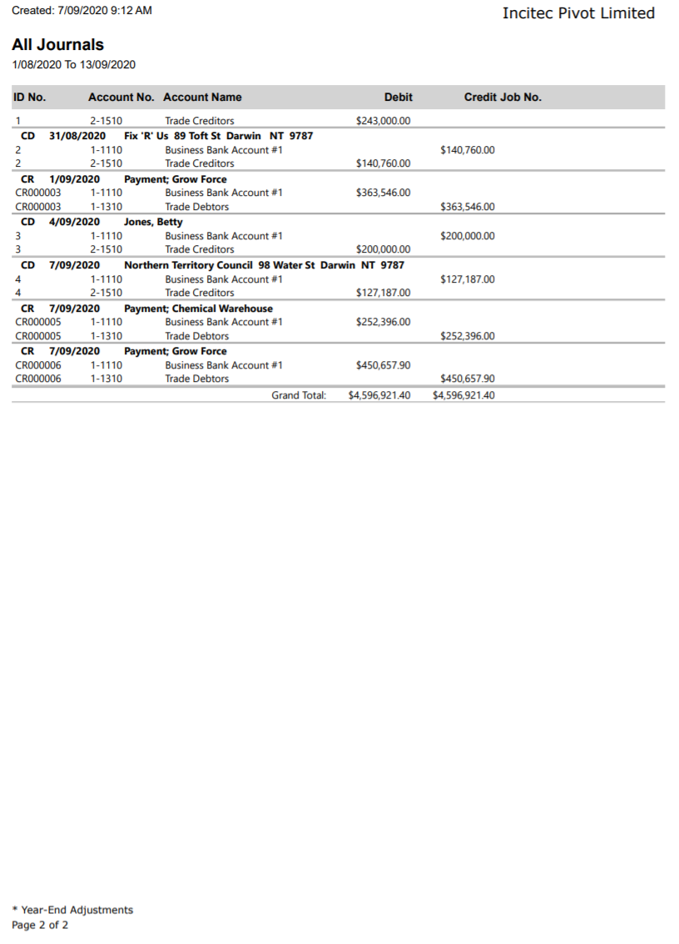
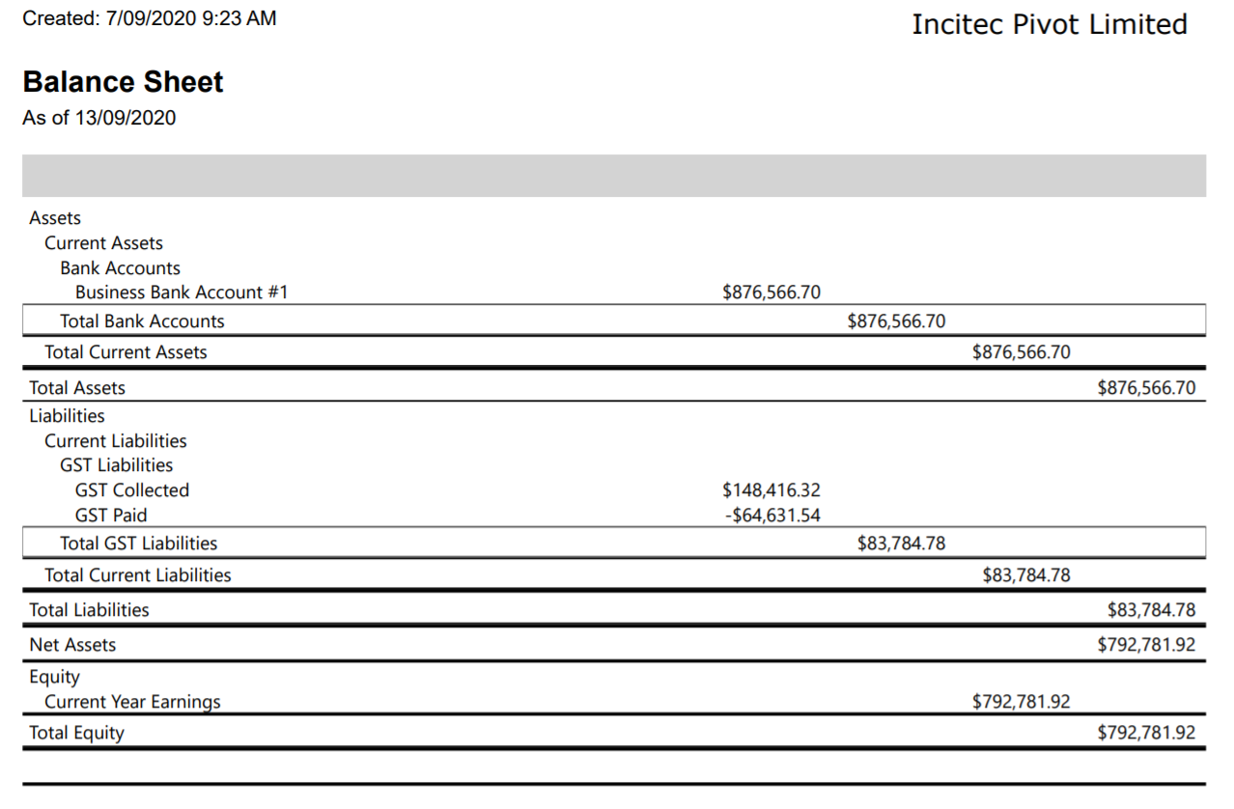
Balance Sheet:
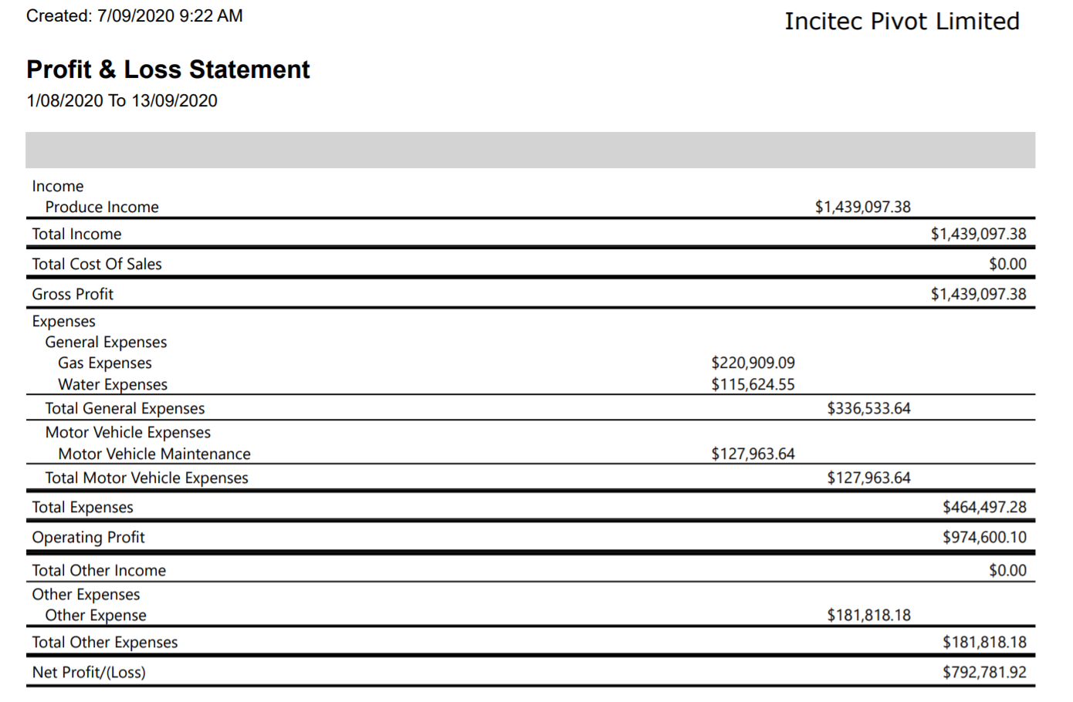
Income Statement (Profit and Loss Statement):
Statement of Cash Flow:
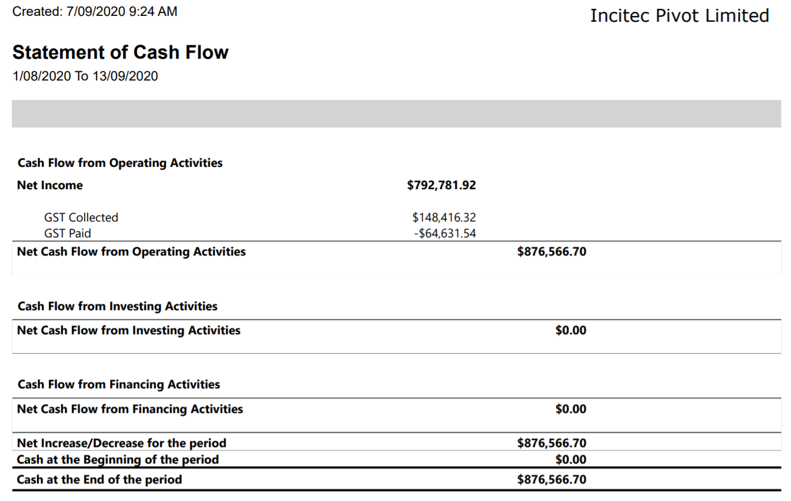

Thoughts and Findings:
While completing this step I cemented what I learnt in the training and set up videos for step 8. I felt this was a good way to remember what I had learnt and put it into practice. I would have preferred being able to enter transactions that I didn’t make up myself, purely because it would have been good to read off an invoice for the purchases and create invoices for sales and make sure I am entering the details from the documents correctly. However, the process of thinking what transactions my company would have in their operation was a good researching task.
I believe this was the first time looking at an All Journal report, so I took my time processing what everything meant. I can see a few abbreviations; SJ – Sales Journal, PJ – Purchases Journal, CR – Cash Revenue? And CD – Cash Debit? not too sure on the last two though. I can also see the journal separates the GST collected and GST paid under different account names and numbers instead of in with the figure I put for the hypothetical transactions in the trade credit and trade debit accounts. This allows the company to see what portion of the transaction is for GST. I can see at the end of the All Journal the grand total in the debits and credits is the same, it balances. This shows to me that the journal reports all coming in and going out transactions for the selected period in order of being entered into the software.
The biggest discovery I had from looking at the balance sheet is seeing how much GST my company collected and is to pay for this period’s transactions. Once again, because it is all base on hypothetical transactions the only asset I have is the bank account and the only liability is the GST component. Using the fundamental equation of accounting I can see, asset minus liability equals equity. Having a play around with the equations helps to reiterate how each total is determined.
ASSET – LIABILITY = EQUITY
$876,566.70 - $83,784.78 = $792,781.92
When first looking at the income statement I wondered what happened to my hypothetical transactions, why are the figures different? Then I checked back at the All Journal report and it made it all clear again. The purchases transactions are all included in the income statement without GST included. Checking back through my notes from when we learnt about GST and of course, income statement and balance sheet excludes GST and cash flow statement usually includes GST, but we will see what mine has done shortly. I can see in the income statement it has categorised the expenses just as I selected when entering the data into MYOB. Using calculations to work out totals I find is the best way to revise how everything is calculated. So, in the statement I can see my expenses ($464,497.88 + $181,818.18) are taken from my income ($1,439,097.38) which leaves the profit, in this case $792,781.92.
Investigating the cash flow statement there is not a whole lot to look at due to the fact it only includes my ten hypothetical transactions and nothing from previous months. However, I can see the net income is the same figure as my profit and loss statement ended on and also the equity in my balance sheet. Looking at the figures under the heading of net cash flow from operating activities I can see this is the figure of all my income minus all my expenses including GST, which also matches my bank account asset from the balance sheet. This is different to my profit of course because from this amount the company would need to pay its tax liability to the government.
Being an accounting novice and not having the experience a lot of others might have definitely meant using my calculator to crunch numbers to investigate different equations and also refer back to my notes to help analyse the reports. The more I look at financial reports the more I am becoming familiar with what they are telling me and the more I understand them.
Overall, looking through the four different reports and discovering how they all link to one another and intertwine the transactions really helped me grow my knowledge on financial reports of not only my company (hypothetical and actual annual reports) but also the process company’s go through. It is important to understand the different reports as they all show something slightly different but equally are important for a company.

