ACCT11081 Assignment: Step 3
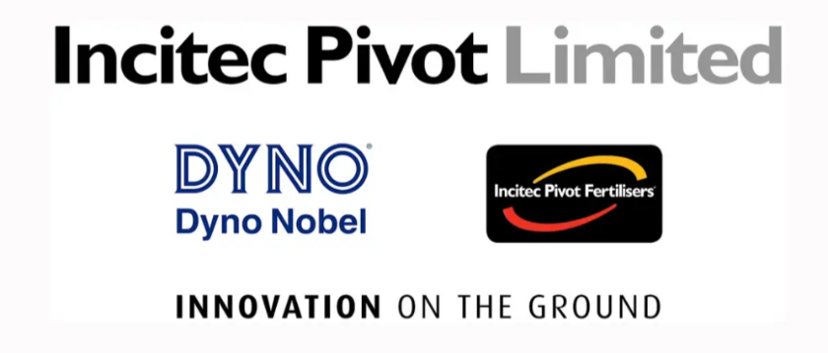
Melissa Sergiacomi 12099798
For this assignment I have been given the company Incitec Pivot Limited (IPL) and just like in ACCT11059 it is a company I have never heard of but will become very familiar with over the next few weeks. I would have loved to be given a retail company that I purchase goods or services from to get a greater understanding of their financial statements and annual reports. However, I am happy to again work with a company that has the agricultural aspect involved, as I grew up on an agricultural farm. Although I completed ACCT11059 over twelve months ago now, I have found IPL’s annual reports a little easier to understand then Select Harvest (my firm for ACCT11059). I believe this is largely due to the experience of reading through an annual report previously and remembering there is a lot in the report I don’t need to absorb and that I just need to get a good idea of what is happening in and around IPL and of course the financial statements.
Researching through IPL’s website, annual report, and news articles I have learnt a lot about the company’s history, what they do and a little about what they plan to do. IPL is made up of two business; Dyno Nobel and Incitec Pivot Fertilisers, which are supported by global manufacturing capabilities. Dyno Nobel is a global leader in the commercial explosives industry with 32 manufacturing facilities on 3 continents, including state of the art initiation system facilities in United States, Australia, and Mexico. Dyno Nobel is the only explosives provider in the world to offer complete line of commercial explosive products and services. This is achieved by providing a full range of reliable explosive products from manufacturing plants all over the world and blasting services from a distribution network unmatched in the industry.

Incitec Pivot Fertilisers (IPF) help farmers maximise productivity by being a key supplier of Australia’s soil health and nutrition needs. Not only do IPF have extensive fertilisers range for all major farm types and conditions but also provide services such as agronomy and testing to find the right fertiliser for the right farmer.
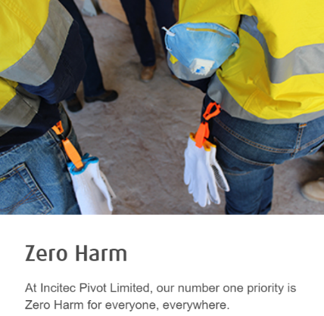
Investigating through the annual report of IPL it can been seen some of the strategies they use in their company. These strategies are critical if a company wishes to operate globally and at the same time be successful in making a profit. The first that stands out is Zero Harm, which from the annual report seems to be an area that is of extremely high importance for IPL. They have a number of strategic drivers, but zero harm is discussed and measured in a number of times in a number of different graphs and tables throughout the report. Dealing with explosives and chemicals this is understandable and to be expected for IPL to be proactive in their strategies. From my investigations so far, I believe they are successful in their strategic plan for zero harm and take it very seriously.
Environmental impact is another key aspect IPL must be proactive in their strategies. IPL must, and from reading their annual report and website they are, manage issue that are most material to the long-term sustainability if its business and the environment in which they operate.
Having a look at IPL’s financial statement both answered questions and produced more questions. Again, the knowledge I gained from previously reading a company’s annual report definitely helped me in this step. To begin with I looked at the income statement and can see the revenue is increasing gradually over the past 4 years but profit for the year went up by more than double from 2016 to 2017 but then a big decrease to 2018 and again to 2019. Expenses seem to have increased each year so that explains some, but income tax expense/benefit amount has a big variation from -$70.9million in 2017 to $18.1million 2018, as seen below. Why is there such a difference in tax expenses/benefit? Most other expense totals in the income statements are similar between 2016 and 2019 expect “asset impairment write-downs” (restructuring costs included in this heading in 2016 and 2017), is this the cause of the big difference in income tax?
Exploring the balance sheet, I can see the firm’s assets have gently increased each year and liabilities generally have increased over the four years apart from a very minor decrease from 2016 to 2017. This asset and liability comparison shows the equity does not fluctuate much over the four year. I have questions about “reserves” under equity heading, I’m not sure what they are but go from -$187.3million to -$197.9million in 2016 and 2017 respectively to -$55.4million to -$19.9million in 2018 and 2019 respectively. Why such a big difference when equity itself only slightly changes overall?
Studying the cash flow statement, I can see the profit after tax for the year of course matches the figures in the income statement under the profit for the year heading. It shows 2018 was the better year over the four-year period. Investigating my tax question from the income statement in the cash flow statement I can see in 2016 and 2017 there is a heading of “deferred tax expense/benefit, as well as current tax expense. Is this from a previous timeframe because it is deferred? I see adding deferred and current tax expense together from cash flow equals the income tax expense/benefit in the income statement in 2016 and 2017 but why no deferred amount in 2018 and 2019? Is it because 2017 was a benefit not an expense to be spread over the next couple years?
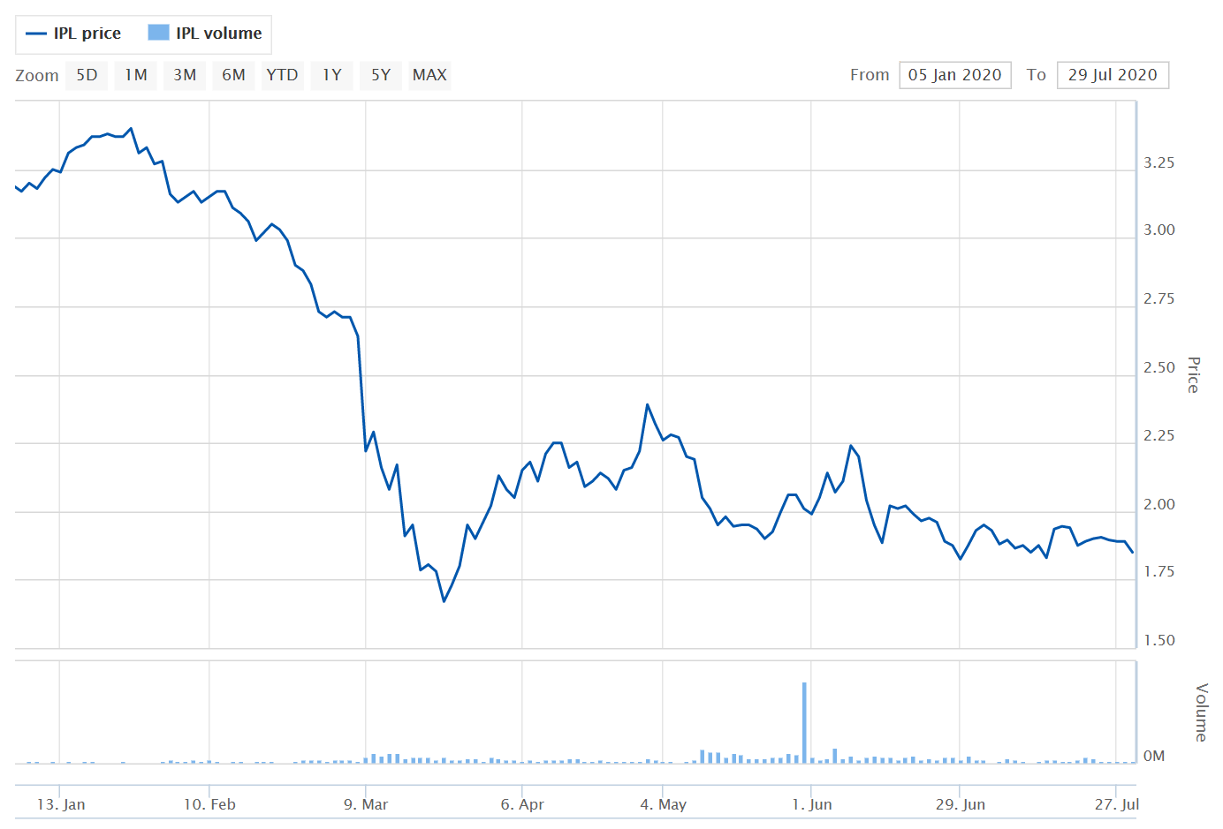
One big factor I did see by just looking at the statements for IPL is that they are all in millions, to me this straight up means they are a large and successful company. This is confirmed on their annual report “at a glance” summary where they state they have 5000 employees, 66 manufacturing facilities that produce 3million tonnes of ammonium nitrate and 2million tonne of fertiliser in their world class technology program. I wonder however, what has caused their share price on ASX to drop from $3.4 on 24th January 2020 to $1.89 on 28th July 2020 investigating this further I discover a big reason is of course, COVID-19.
News article from The Sydney Morning Herald explains IPL are strengthening their balance sheer via a $675million capital raise in a pre-emptive move in the uncertain economic times, COVID-19. IPL also decided to not sell its fertiliser business IPF. COVID-19 is really causing major economic disruptions to businesses from all industries and of all sizes, so it’s not a surprise to see even such a large company like IPL also have to put strategies in place. From reading their article on their website, IPL have developed and continuing to put in place a number of strategies to help farmers to have a continuity supply of fertilisers for their crops during the COVID-19 pandemic. In another article I found (and this is pre COVID-19), IPL have provided $400,000 in relief to support regional communities, farmers and customers impacted by the bushfire crisis in Australia in January 2020. I cannot find this in the annual report of financial statements because I only have up until 2019 but I wonder where that would show up in the financial statements? Obviously in expenses but have the made donations in the years I do have? If so where would that be shown? Do they claim is as a tax deduction? We can claim a donation over $2, so surely, they would claim something for such a large donation.
After spending a far bit of time looking through the annual report, financial statements, and the company’s website I am fairly happy with where I am at this stage. I have no real concerns as I know I will dissect and discover more about my company, gain a better understanding of how it all works and answer a lot of my questions as I process with the assignment and the unit material.
Discussions…..

